# Source Control Snapshot(S2)

## GitHub Repository

GitHub Link:

<https://github.com/profiteroles/RAD>

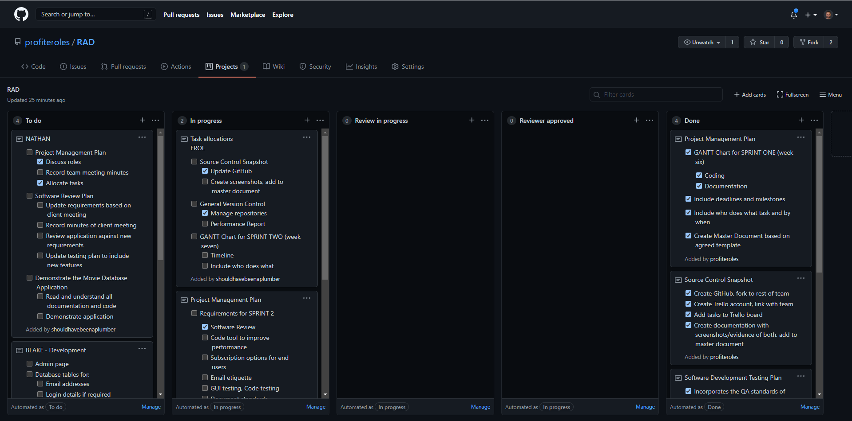

Figure 13- GitHub repository

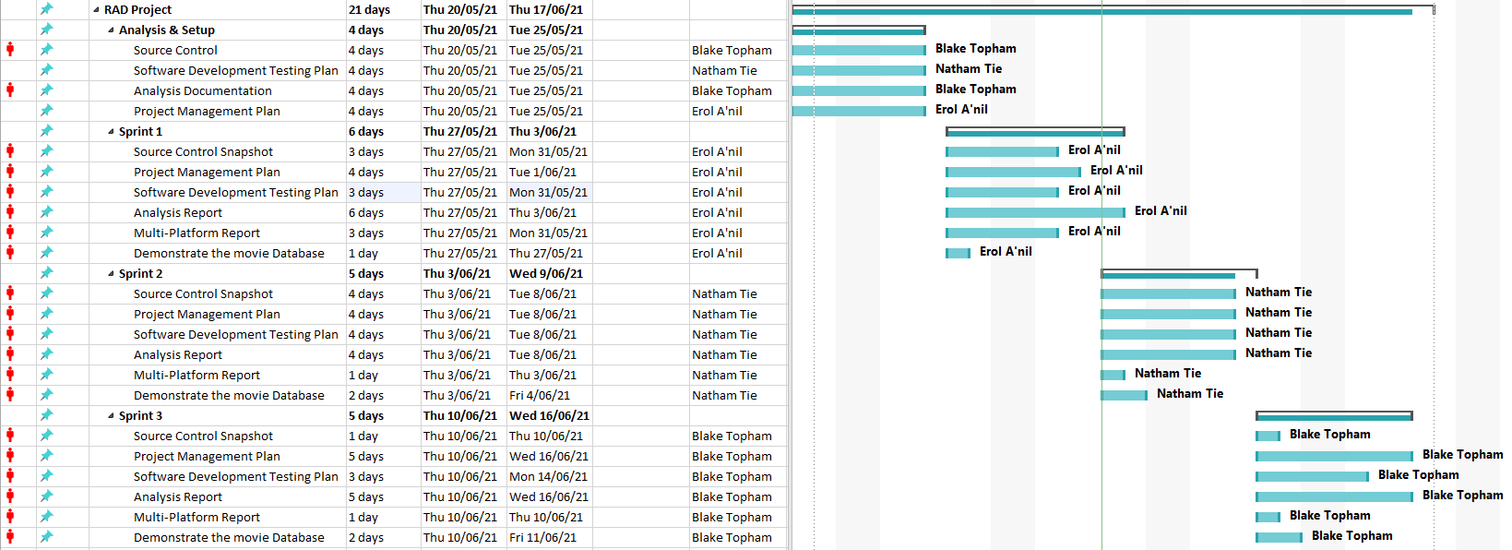

Figure 14- GANTT chart sprint two